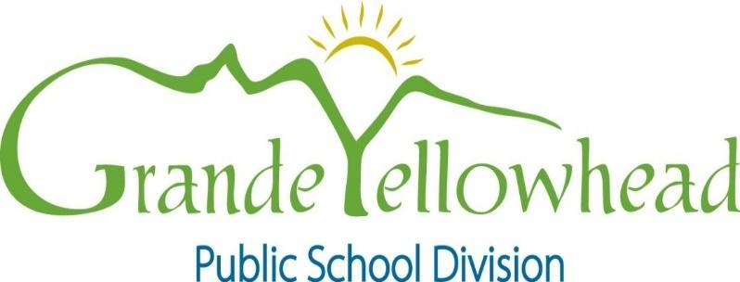

Grande Yellowhead Public School Division
BOARD OF TRUSTEES
SPECIAL MEETING 202403
A G E N D A
March 19, 2024
Meeting Number 10

OUR VISION
Our Division endeavours to provide each Grande Yellowhead Public School Division (GYPSD) student with the opportunity to fulfill their potential and pursue their dreams.
OUR MISSION
Every GYPSD student will graduate with the knowledge and skills to pursue their post-secondary goals.
OUR PRIORITIES
Student Learning
Teacher, Support Staff, and Leader Excellence
Community Engagement
System Health and Wellness

Grande Yellowhead Public School Division
NOTICE OF MEETING 202403
A SPECIAL MEETING OF THE BOARD OF TRUSTEES HAS BEEN CALLED IN ACCORDANCE WITH THE EDUCATION ACT – ALBERTA REGULATION 82: BOARD PROCEDURES REGULATION SECTION 3.
March 19, 2024
1:00 PM
Grande Yellowhead Public School Division
A G E N D A
- CALL TO ORDER at 1:00 PM

  - Land Acknowledgement
  - Approval of the Agenda

- ACTION ITEMS
2.1 Motion to Move In-Camera

- IN-CAMERA: Land, Legal, Labour

- ADJOURNMENT

